Software Requirements Specification

for
Authentication System
Version 3.0 approved
Prepared by
Tamara Nicole Rodríguez Luna
Jeffrey Daniel Leiva Cascante
Technological Institute of Costa Rica
May 29, 2023
Table of Contents
Table of Contents ii
Revision History ii
1. Introduction 4
1.1 Purpose 4
1.2 Document Conventions 4
1.3 Intended Audience and Reading Suggestions 4
1.4 Product Scope 4
1.5 User Story 5
1.6 Definitions, Acronyms or Abbreviations 6
1.7 References 7
1.8 Overview 7
2. Overall Description 7
2.1 Product Perspective 7
2.2 Product Functions 8
2.3 User Classes and Characteristics 19
2.4 Operating Environment 20
2.5 Design and Implementation Constraints 20
2.6 User Documentation 21
2.7 Assumptions and Dependencies 21
3. External Interface Requirements 21
3.1 User Interfaces 21
3.2 Hardware Interfaces 22
3.3 Software Interfaces 22
4. System Features 30
4.1 User interfaces 30
5. Other Nonfunctional Requirements 43
5.1 Performance Requirements 43
5.2 Safety Requirements 43
5.3 Security Requirements 43
5.4 Software Quality Attributes 44
5.5 Business Rules 44
6. Other Requirements 44
Appendix A: Glossary 44
Appendix B: Analysis Models 45
Appendix C: To Be Determined List 54

Revision History
Name | Date | Reason For Changes | Version
Tamara Rodríguez  Jeffrey Leiva | 10-5-2023 | Document creation. | 1.0
Tamara Rodríguez  Jeffrey Leiva | 16-5-2023 | Changes to sections 1.1 - 1.7. | 1.1
Tamara Rodríguez  Jeffrey Leiva | 18-3-2023 | Section aggregation 1.6 - Definitions, Acronyms or Abbreviations, Creation of section 2 and 3 of the document. | 2.0
Tamara Rodríguez  Jeffrey Leiva | 24-5-2023 | Changes on section 2 and 3 of the document. | 2.1
Tamara Rodríguez  Jeffrey Leiva | 29-5-2023 | Creation of sections 4, 5 and 6. | 3.0

Introduction

Purpose
The purpose of the project exists due to a need for the members of a university to be able to authenticate themselves through an email and password. Authentication is extremely vital in this world of technology due to security and data privacy issues. This system allows authentication by means of a login that would be the access, but it is not limited only to function as a login, it also has the options of registration, account management and system password change. It is very important that the system reflects usability, security and good software development practices.

Document Conventions
Doesn’t Apply.

Intended Audience and Reading Suggestions
This document provides explanations for the following audiences: system users
(Principal, financial principal, students, teachers, administrative and providers), technical domain users (software developers) and all possible stakeholders of the system.
This document is divided into six numbered sections, they are: introduction, overall description, external interface requirements, system features, non-functional requirements, and other requirements. The scope of this document if you are an user who is unfamiliar with requirements engineering or technology in general, it is recommended that you focus on sections 1 and 2 of the documents because they do not require prior technical knowledge for their correct understanding. If you want to know more about the interface or non-functional requirements of the system, you can read sections 4 and 5 of the system. Section 3 is for system developers because of its terminology and that it focuses on understanding the system architecture.
If you are a developer, section 1 and 2 encompasses the idea of what the system should do and how it behaves, as well as understanding the points of view of the different users of the system. In section 3 you can find the architecture and functionality of the system with all its focus on classes, objects, attributes and other important to understand the internal structure of the system.
Section 4 is about the interface of the system and how each button, window and functionality should look and understand, section 5 is about the non-functional requirements such as appearance, security and so on. Finally, section 6 deals with the system requirements that include the UML diagrams that allow us to communicate with the non-relational database as well as with the use cases used and implemented in the system.

Product Scope
The product consists of an authentication system for a college with four principal functions that make up the entirety of the scope that the product covers. Those functionalities include: registration of users into the system, self-administration of the details of a user account, change of the password linked to a user account and the log-in to the system functionality. Together, these functionalities give form and define a scope for the product.
In general, the overarching goal of the system is to authenticate users through an email and a password and give them access to the different options that the system offers, these include the administration of the account’s data as well as the possibility to change the password. However, the system is designed so that new functionalities can be added in the future if the users of the system require them.
In addition; if they do not have an account, there is the functionality of self-registration in the system as stipulated in the requirements given for the architecture of the system. Furthermore; the system also complies with the specified requirements for self-administration of the user account as well as including the functionality of the password change requested by the users. Finally, the system also complies with all the non-functional requirements specified; these include the feeling and look of the system as well as naming and code conventions that give the system structure cohesion.

User Story
This section is concerned with the detailed description of the four user stories that describe the use cases and the functionality that the system described in this specification needs to implement and deploy. These user stories are linked to the role of a user.

The first user story explains the requirements as per the user point of view for the use case of the registration in the authentication system, the expected behavior of the system at that stage, any alternatives that could apply to the design as well as the exceptions to the particular use case.

As a user of the authentication system, I need to be able to register into the system by creating an account with my personal information, it could be my email address, my physical address, name, surname and of course, a password. Furthermore, the password field should not be plainly visible; it must be hidden, even when I write the password I want. I would like the fields of the registration to be labeled as to which one corresponds to which information.
Likewise, there should be a button to confirm my registration; when I do click it, I would like to see a message that confirms that I am registered in the system. If for some reason I forgot to enter information into a field or I violated some restriction that doesn’t allow the registration I want to see a message that points it out to me so I can fix my mistake. Additionally; there should be a button to go back to the login page, so that I can go when I’m done registering or I want to go back without doing so. If I click the exit button of the window it should close the system without any inconvenience. Finally, the register window of the system should be elegant and welcoming.

The second user story explains the requirements as per the user point of view for the use case of the log-in into the authentication system, the expected behavior of the system at that stage, any alternatives that could apply to the design as well as the exceptions to the particular use case.

As a user of the authentication system, I need to be able to log-in to my account on the system by providing my credentials; these are my email address and chosen password. When I go to the log-in window of the system I want to see the corresponding fields for my credentials, these should be labeled as to which one is for the password and which one is for the email address. Moreover, the password should not be plainly visible, even when I’m writing it.
There should also be a button to confirm the log-in; when I do click it, I want to see the homepage of the system if my credentials were right. If for some reason, I did not enter the corresponding information into a field or I violated some restriction I want to see a message that explains what I did wrong so I can correct it. Also, if the credentials do not match with my account, I should not be able to log-in. Additionally, there should also be a link to the register window so that I can register if I don’t have an account. Furthermore, when I click the exit button the system must close and shut down. Finally, the log-in window must have an elegant and welcoming feeling.

The third user story explains the requirements as per the user point of view for the use case of the administration of the user account in the authorization system, the expected behavior of the system for the particular requirement, the alternatives that could apply to the design as well as the exceptions for the presented use case.

As a user of the authentication system, I want to be able to change or update the information of my account in the system. For this, in the homepage I want to see an option that lets me administer my information. When I click that option I want to see a window that displays my current information as well as a button with the option to edit it. When I click the edit button I want the fields displaying my information to be able to receive changes. So, when I’m done making the changes I want to be able to save them by clicking a button. If for some reason I left fields blank or I violated some restriction I want to see a message with the error so that I can fix it to proceed with the changes and the displayed information should return to the one that was previously shown. If the changes were successful, I would like to see a message pointing it out and the updated information in the window. There also should be a button to go back to the homepage and when I click it I want to see the homepage with the options of administering my account and the change password option. Furthermore, when I click the exit button the system must close and shut down. Additionally, the window must have the same feeling as the others of the system.

The fourth user story explains the requirements as per the user point of view for the use case of changing the password of the account in the authorization system, the expected behavior of the system for the particular requirement, the alternatives that could apply to the design as well as the exceptions for the presented use case.

As a user of the authorization system, I want to be able to change the password of my account in the system. In the homepage of the system I want to see an option for the change of password and when I click it, the change password window should be shown. In the window for the change of password there should be at least three fields, one that is for the current password, for security reasons and two more fields for the new password and its confirmation.
There should also be a button to confirm the change when I’m done providing the information. When I click the said button and everything is correct I would like to see a message that confirms the change. If for some reason I left blank fields or the information I typed is wrong, I want to see a message that tells me what went wrong so I can correct it and try again. In addition to this, there should be a button to go back to the homepage and when I click it I want to see the homepage with the options of administering my account and the change password option. Furthermore, when I click the exit button the system must close and shut down. Finally, the window must have the same feeling of elegance and welcoming as the others of the system.

The previously specified user stories cover the requirements of the authorization system, both functional and non-functional as per the user point of view. They will serve as a guideline for the next sections of the system specification as well as the way the system should be architectured, programmed, polished and tested to achieve the desired results.

Definitions, Acronyms or Abbreviations
Authenticator System: It is a software that limits and allows the registration of unauthorized users.
Bootstrap is a free and open source CSS framework aimed at mobile and responsive front-end web development.
CSS: A style sheet language used to describe the presentation of a document written in a markup language such as HTML.
Desktop: refers to the window where the system functionalities are found.
Express: It is a Javascript library, it is designed to create web applications and APIs.
Front-End: is the practice of converting data to a graphical interface, through the use of HTML, CSS, and JavaScript, so that users can view and interact with that data.
HTML: HyperText Markup Language.
IDE: Integrated Development Environment.
JavaScript: It is a programming or scripting language that allows you to implement complex functions in web pages.
Main: It is where the program begins its execution. It is the function that controls the flow of the program.
MongoDB: is a non-relational database management system.
Node.js – Asynchronous event-driven Javascript runtime that can build scalable networked applications.
Non-relational: is one that does not use the tabular layout of rows and columns.
Blind: Function that prevents you from seeing what was written in a text field.
Responsive: It is a design and development philosophy whose objective is to adapt the appearance of web pages to the device that is being used to visit them.
Salt – Comprises random bits that are used as one of the inputs in a key-derivative function.
Self-service: It is a philosophy that establishes that the user attends to himself, does not need any employee to carry out an action.
Unauthorized user: person that is not registered on the system and has no access to the system.
User: person that is registered on the system and has access to the system, The user of the system can be any person from the university, be it principal, financial principal, students, teachers, administrative and providers.

References
The page where the MongoDB non-relational database is located is:
https://www.mongodb.com/

Overview
In the next section of the document you can find the general description of it, where the use cases of the users and characteristics of the project such as its design, dependencies and others. The idea of ​​the next section is to understand the product, the prospects, functionality and other important aspects.

Overall Description

Product Perspective
The authenticator system is built on a website, it could be used on any system that needs to authenticate its users. For it to work you must need a browser and a connection to the MongoDB database.
The system allows you to manage user access to system functionalities such as managing your account and changing your password, as well as allowing unauthorized users to create a new account and access the system with this created account.

Product Functions
The system is made up of four main use cases: access, registration, account management and password change. They are described in the following class diagram:
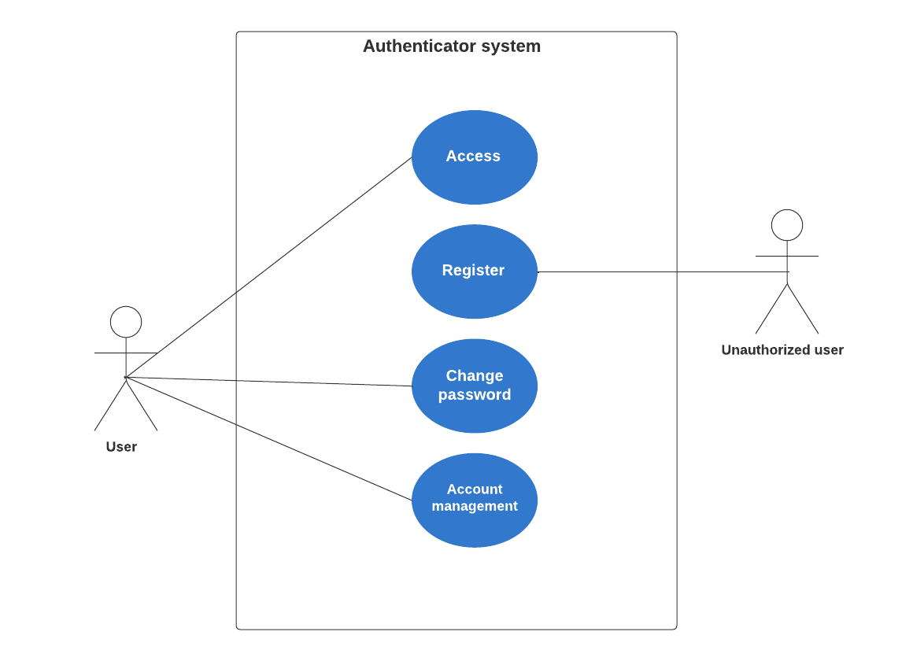
Figure 2.2.1: Use case diagram
List of use cases:

Actor | Function
User | Access
Unauthorized user | Register
User | Account management
User | Change password

Access Use Case
Use Case ID: | SRS-000
Use Case Name: | Access
Created By: | Jeffrey Leiva | Last Updated By: | Tamara Rodríguez
Date Created: | March 4, 2023 | Date Last Updated: | May 24, 2023

Actors: | User
Description: | Functionality that allows access to the system by a duly authorized actor by identifying their credentials.
Trigger: | The user clicks on the login button.
Preconditions: | The user must have a profile and credentials previously registered in the system, that is, an email and password associated with a previously registered account.  The data must be contained in the system's MongoDB database so that the data given by the user can be verified.
Postconditions: | The user has access to the system and its functionalities.  You are not allowed access if you are an unauthorized user or your credentials are invalid.
Normal Flow: | The user enters the login window.  The user enters his credentials, that is, the email and password in the corresponding boxes.  The user clicks on the "Next" button.  The system verifies that the data entered coincides in the database and that they are correct.  The user logs in successfully.  The system shows the desktop to the user.
Alternative Flows: | After the first step the user can do- the following alternative:  2. The user closes the window.  3. The user is redirected to his browser if he has other windows open or to the desktop of the computer.
Exceptions: | In step 4, the system rejects the user's data because they are incorrect or did not match, so it would follow the following flow steps:  4. The system verifies that the data entered does not match in the database and that they aren't correct.  5. The system displays an error message.  6. The user returns to point 2 of the normal flow.
Includes: | Verify the existence of the user in the system database  Verify login credentials against the database.
Priority: | 1
Frequency of Use: | Daily.
Business Rules: | The system must be under Microsoft-Like.
Special Requirements: | The access must be self-service.  - The system must be developed with Microsoft-Like.
Assumptions: | Access to the system was developed to be authenticated by means of an email and password.  The MongoDB database is used for data persistence.
Notes and Issues: | Doesn’t Apply.

Register Use Case
Use Case ID: | SRS-001
Use Case Name: | Register
Created By: | Jeffrey Leiva | Last Updated By: | Nicole Rodríguez
Date Created: | March 4, 2023 | Date Last Updated: | May 24, 2023

Actors: | User.
Description: | System functionality that allows an unauthorized user to register.
Trigger: | Enter the Login window, then click the register button.
Preconditions: | The database must be available to store the new information.  The unauthorized user must have a valid email for registration.
Postconditions: | The unauthorized user happens to have a valid account and be a normal user of the system.
Normal Flow: | The system presents the login window.  The unauthorized user presses the register button.  The system presents the form requesting user data.  The unauthorized user registers data in the form, fills in the spaces and presses the confirm button.  The system verifies information.  The system displays a message that the registration was successful.  The user is returned to log in.
Alternative Flows: | After the first step the user can do- the following alternative:  2. The user closes the window.  3. The user is redirected to his browser if he has other windows open or to the desktop of the computer.  After the third step of the system the following could happen:  4. The user closes the window.  5. The user is redirected to his browser if he has other windows open or to the desktop of the computer.  After the second step of the system the following could happen:  3. The user presses the return button.  And the user is back at step 1 of the normal flow.
Exceptions: | After step 5 the following exception may occur:  6. The system displays an error message because the email is already associated with another account.  7. The unauthorized user remains in the registration window and returns to step 4 of the normal flow.  After step 5 the following exception may occur:  6. The system shows an error message because the mail space is empty.  7. The unauthorized user remains in the registration window and returns to step 4 of the normal flow.  After step 5 the following exception may occur:  6. The system displays an error message because the password space is empty.  7. The unauthorized user remains in the registration window and returns to step 4 of the normal flow.  After step 5 the following exception may occur:  6. The system displays an error message because the name space is empty.  7. The unauthorized user remains in the registration window and returns to step 4 of the normal flow.  After step 5 the following exception may occur:  6. The system displays an error message because the address space is empty.  7. The unauthorized user remains in the registration window and returns to step 4 of the normal flow.
Includes: | The database must be available to store the new information.  Valid email verification.
Priority: | 2
Frequency of Use: | Daily
Business Rules: | The system must be under Microsoft-Like.
Special Requirements: | The access must be self-service.  - The system must be developed with Microsoft-Like.
Assumptions: | The registration to the system was developed to be authenticated by name, email, address and password.  The MongoDB database is used for data persistence.
Notes and Issues: | Doesn’t Apply.

Change password Use Case
Use Case ID: | SRS-002
Use Case Name: | Change password
Created By: | Jeffrey Leiva | Last Updated By: | Nicole Rodríguez
Date Created: | March 4, 2023 | Date Last Updated: | May 24, 2023

Actors: | User
Description: | Functionality that allows the duly authorized user to change their password.
Trigger: | Have successfully logged in, have the Landing Place window displayed and have clicked on the option to Change Password.
Preconditions: | The user must exist in the database.  The user must have successfully accessed the system.  3. The user must have clicked on the change password functionality.
Postconditions: | The password is successfully updated in the database.
Normal Flow: | The user makes successful access to the system.  The system displays the desktop window. (Landing Place)  The user clicks on the change password button.  The user displays the password change form.  The user fills in the fields for the current password, the new password, and the confirmation of the new password.  The user clicks on the confirm button.  The system displays a successful change message.  The user is returned to the desktop. (Landing Place)
Alternative Flows: | After the first step the user can do- the following alternative:  2. The user closes the window.  3. The user is redirected to his browser if he has other windows open or to the desktop of the computer.  After the fourth step the user can do- the following alternative:  2. The user closes the window.  3. The user is redirected to his browser if he has other windows open or to the desktop of the computer.  After the fifth step the user can do- the following alternative:  2. The user closes the window.  3. The user is redirected to his browser if he has other windows open or to the desktop of the computer.  4. The password change does not happen because the confirm button is not pressed..
Exceptions: | After step 5 can occur:  6. The system shows an error because the current password is not correct.  User proceeds to step 5.  After step 5 can occur:  6. The system shows an error because the new password and the password confirmation do not match.  User proceeds to step 5.
Includes: | Check the existence of the user in the database  Update of the password in the database.
Priority: | 1
Frequency of Use: | Daily.
Business Rules: | The system must be under Microsoft-Like.
Special Requirements: | The access must be self-service.  - The system must be developed with Microsoft-Like.
Assumptions: | 1. In the password change we assume that the format of the password change would be the spaces of the current password, the new password and confirm the same.  2. The MongoDB database is used for data persistence.
Notes and Issues: | The password uses an encryption system for system security.

Account Management Use Case
Use Case ID: | SRS-003
Use Case Name: | Account Management
Created By: | Jeffrey Leiva | Last Updated By: | Nicole Rodríguez
Date Created: | March 4, 2023 | Date Last Updated: | May 24, 2023

Actors: | User
Description: | Functionality that allows the duly authorized user to manage their account and account data.
Trigger: | Have successfully logged in, have the Landing Place window displayed and have clicked on the option to Manage Account.
Preconditions: | The user must exist in the database.  The user must have successfully accessed the system.  The user must have clicked on the change password functionality.
Postconditions: | Changes made to the account are saved.
Normal Flow: | The user makes successful access to the system.  The system displays the desktop window. (Landing Place)  The user clicks on the manage account button.  The user displays the managed account change form.  The user fills in the information field that he wishes to update.  The system displays a successful change message.  The user is returned to the desktop. (Landing Place)
Alternative Flows: | After the first step the user can do- the following alternative:  2. The user closes the window.  3. The user is redirected to his browser if he has other windows open or to the desktop of the computer.  After the fourth step the user can do- the following alternative:  2. The user closes the window.  3. The user is redirected to his browser if he has other windows open or to the desktop of the computer.  After the fifth step the user can do- the following alternative:  2. The user closes the window.  3. The user is redirected to his browser if he has other windows open or to the desktop of the computer.  4. The change of any of your data does not occur because the confirmation button is not pressed.
Exceptions: | After step 5 may occur:  6. The system displays an error because the data entered is in an invalid format.  The user continues with step 5.
Includes: | Check the existence of the user in the database  Updating of data in the database.
Priority: | 1
Frequency of Use: | Daily.
Business Rules: | The system must be under Microsoft-Like.
Special Requirements: | The access must be self-service.  - The system must be developed with Microsoft-Like.
Assumptions: | 1. It is assumed that all account data can be changed at any time. 2. The MongoDB database is used for data persistence.
Notes and Issues: | Doesn’t Apply.

User Classes and Characteristics
In the system there are authorized users and unauthorized users, those who are not authorized can register in the system and at the end of the registration they become users of the system and as such; they can be authorized. Authorized users can access the system and its functionalities such as account management and password change.

The user base of the authorization system is made up of the different members that make up the college environment. These include; to name a few: students, professors, administrative personnel, financial chief officers, and providers. All of the previous mentioned will potentially make use of the system and its functionality. Accordingly; we must make a description of the characteristics of the defined users; the intention is to cover a broad set of them and this will be done in the next paragraphs.

The first characteristic that is worth mentioning is that all of the users mentioned above have an extensive record of using the Windows operating system; and as such; the vast majority of them have become accustomed to the applications that are available in it. It is crucial to understand this because the system must be developed taking into account the guidelines given by Microsoft to build, test, and deploy the software. Foremost; the ease of usability, the look and feel of the system should be alike to that of Microsoft’s applications; these will be the point of discussion in the following characteristics in a detailed manner.

A second important characteristic of the users is that most of them have a certain degree of knowledge on the security and disposal of their data because the applications and systems they have used comply with high standards of security and they remove the additional difficulty this imposes off of the user’s shoulders. This characteristic matters to us because it englobes a wide range of sections that we must take into account when developing the system; some of them include the following: the manner in which the user’s data is handled, how sensitive or personal information is treated, as well as taking into account guidelines to guarantee the security of their account, including passwords and the corresponding encryption.

In general, all of these users or the majority of them have some knowledge in how to use these types of systems; and they are accustomed to them being self-service and end-user oriented. This means they want to be able to manipulate the system on their own without the need of help from the IT department or others. The users want to be able to do what they consider to be simple tasks like changing their password or account information by themselves. This is due to their previous background and experience in similar systems where most of the available functionality is self-serviced.

In conclusion It is of the utmost importance to take consideration of the previously defined user characteristics so that the product can comply and meet all the standards of quality and usability expected by all of the users of the system.

Operating Environment
The system is intended for it to be used in a web environment due to it being implemented via JavaScript and Nodejs. The system is designed so that it can be deployed in the browsers more widely used by the Windows operating system as it is the system that most users are accustomed to. Google Chrome and Edge fall in this category as they are two of the most well known browsers by users on this operating system. The software has been tested in both of these browsers, ensuring that it runs in a smooth manner for the end user.

Design and Implementation Constraints
The main constraints of the system are:
- The system must be used on a computer due.
- It must be responsive, so that it adapts to the resolution of any browser and screen.
- The database engine used is MongoDB.
- The system is web type.
- The system must use the self-service philosophy.
- The way to identify a user corresponds to his mail.
- The password must be encrypted.

User Documentation
The user is given a requirements specification.

Assumptions and Dependencies
The main system dependencies are:
- The Internet host service LocalHost.
- The style classes provided by Bootstrap.
- Web use with HTML, CSS and JavaScript.
- Using Node.js.
- The library: express.
- MongoDB database engine.

External Interface Requirements

User Interfaces
The application consists of 3 layers, one for the graphical interface, another for the application and the last one for the persistent data. On the other hand, in the business logic, the type of user who is going to use the interface windows was identified as a normal user or an unauthorized user.

In the interface we can see multiple windows such as Login which consists of two login and registration buttons, in addition to two text fields for the email name and password, the unauthorized user registration window has 4 spaces: name, email email, address and password, in addition to a confirmation button. The desktop window (Landing Place) consists of the window that the user observes to use the system functionalities, in this project are the password change and administration from the account.
the existing user window consisting of an accept button and a text describing the completed action, the data does not match window is to inform the user that the email does not match the entered password, the password not allowed window informs him that the password entered does not comply with the established security standards and has an accept button, the email window does not exist informs the user that he is trying to enter with an email that is not registered in the database and has a button accept, the email exists window informs the user that he is trying to register with an email that is already registered in the database and has an accept button, finally the empty boxes error window tells the user that he still needs to complete a box to register or log in.
The change password functionality is based on three spaces to enter data, the passwords are always masked, the current password, the new password and the confirmation of the new password are entered, as well as a confirm button so that the changes are saved successfully. The account administration functionality consists of entering the data that you want to change and that the previous ones are replaced, the changes must be saved by clicking on the confirm button.
In the application there are functions such as registerUser that receives as parameters all the information that was requested from the unauthorized user, calls the verifyPassword function to confirm that the password complies with the established standards and matches its confirmation, upon receiving the true as return encrypts the password and asks the database to register the user with the data it received, access the system that only receives an email and the password, uses the verifyUser function to confirm that the user exists and the password matches, after confirming it allows access to the system; In addition, it has all the functions to display the different windows of the interface.
The database saves all the information that was requested in the registration of each user and responds to requests to register a new user and search for a user to display the data as needed.
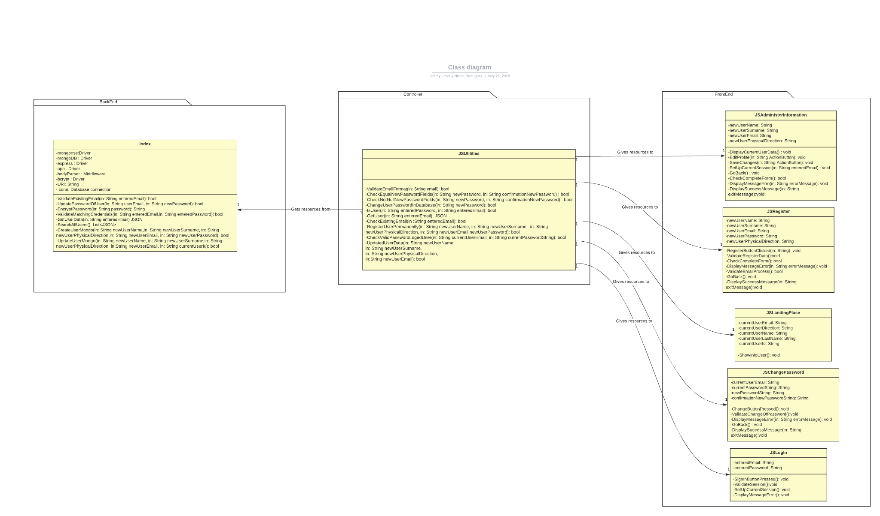
Figure 3.1: Class diagram

Hardware Interfaces
The system is intended for it to be used in a web environment due to it being implemented via JavaScript and Nodejs. The system is designed so that it can be deployed in the browsers more widely used by the Windows operating system as it is the system that most users are accustomed to. Google Chrome and Edge fall in this category as they are two of the most well known browsers by users on this operating system. The software has been tested in both of these browsers, ensuring that it runs in a smooth manner for the end user.

Software Interfaces
3.3.1 Access:
- 3.3.1.1 Priority and description:
The diagram in the next section represents the sequence of execution when logging in. First the unauthorized user enters the system through the browser, the function displays the Login window and the database in this case MongoDB needs to be active. In addition, the Main application creates a new Login Window object to display on the screen to the user. Then the unauthorized user fills in the required fields, which in this case are the username and password, and then through the Login button activate the function to access the system and allow the JSUtilities program to read the data and verify if they match a document in the MongoDB database. If no problem occurs, the database returns true and the JSUtilities screen of the application is displayed on the screen through the browser. Finally, Main frees the memory corresponding to the Login window that was active for the session and it ends its life cycle.
- 3.3.1.2 Stimulus and Response Sequences:
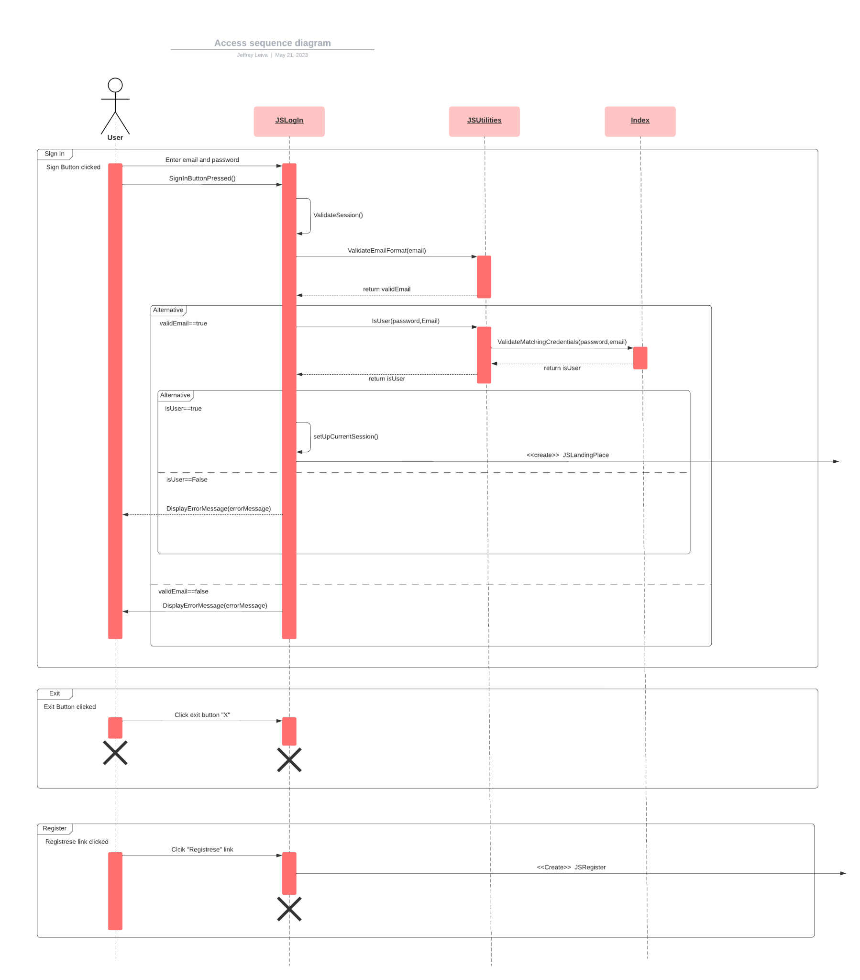
Figure 3.3.1.2.1: Access sequence diagram
- 3.3.1.3 Functional requirements:
- REQ-1: The system must display the Login Window and receive information.
- REQ-2: The system must create a new Login Window object in order to display it.
- REQ-3: The system must process the request of the unauthorized user, validate and consult the user database. Go to figure 3.1.
- REQ-4: The System must verify if the information is in the database and answer if the user exists or not.
- REQ-5: The system should display the main screen once logged into the system.
- REQ-6: The system must erase the memory belonging to the Login Window object once its use has finished.
- REQ-7: The system must ensure that the database of data works correctly.
3.3.2 Register:
- 3.3.2.1 Priority and description:
The diagram in the next section represents the execution sequence when registering a new user. First, when the unauthorized user enters the system in the browser, the function of displaying the Login window is activated, and the Main application creates a new Login Window object to display on the screen to the user. Then through the registration button the user activates the display function of the user form, the JSUtilities application creates a new Registration Window object to be displayed on the screen to the unauthorized user. JSUtilities frees the memory corresponding to the Login window that was active for the session and it ends its life cycle. Then the user fills in the required fields, and then, by means of the Accept button, activate the function of registering a new user to the system and allow the JSUtilities program to read the data and by means of the Verify existing user function if the data of the email is already registered or has an invalid format, in addition to verifying that passwords meet the requirements through the verify valid password function. If no problem occurs, the user will be registered in the database and a message that the registration was successful will be displayed on the user's screen. Finally, JSUtilities frees the memory corresponding to the Login window that was active for the session and it ends its life cycle.
- 3.3.2.2 Stimulus and Response Sequences:
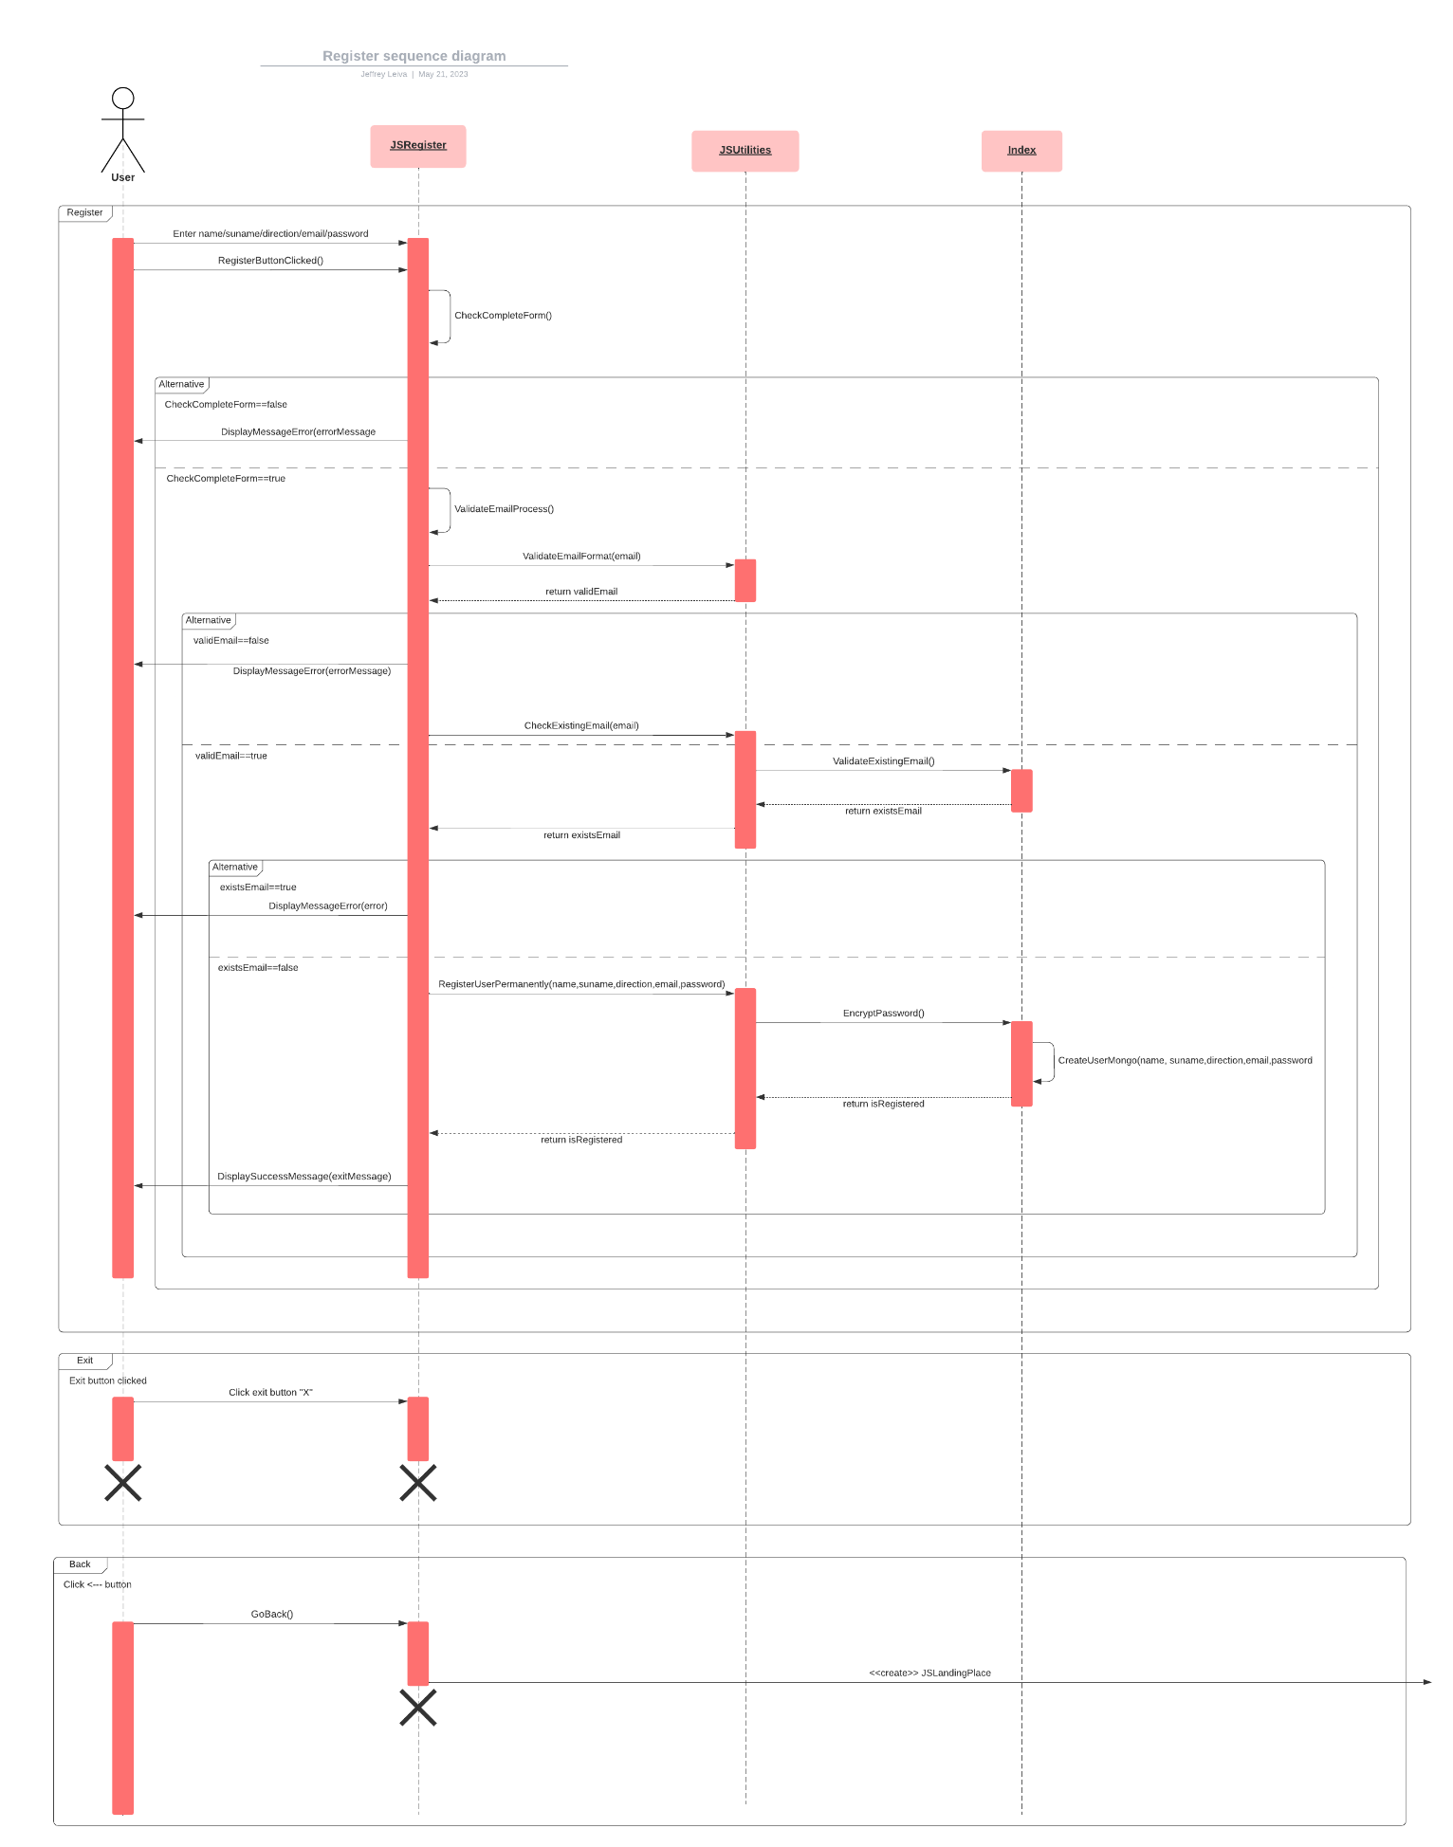
Figure 3.3.2.2.1: Register sequence diagram
- 3.3.2.3 Functional requirements:
- REQ-1: The System must display the Registration Window and receive information.
- REQ-2: The system must create a new Login Window object in order to display it.
- REQ-3: The system must create a new User Template Window object in order to display it.
- REQ-4: The System must process the user's request, validate and consult and add to the user database. Go to figure 3.1
- REQ-5: The System verifies if the information is in the database and responds if the user exists or not.
- REQ-6: The system should display the Registration Complete screen once the user has registered
- REQ-7: The system must erase the memory belonging to the Login Window object once its use has finished.
- REQ-8: The system must erase the memory belonging to the User Template Window object once its use has finished.
- REQ-9: The system must ensure that the database of data works correctly.
3.3.3 Change Password:
- 3.3.3.1 Priority and description:
The diagram in the next section represents the execution sequence when the user wants to change his password. First, when the authorized user should already be logged into the system, the change password window display function is activated and the main application creates a new password change window object to display on the screen to the user. Then, through the change password button, the user activates the function of using the change password form, the JSUtilities application creates a new Landing Place window object to display on the screen to the authorized user. JSUtilities frees the memory corresponding to the desktop window that was active for the session and ends its life cycle. Then the user fills in the required fields, and then through the confirm button and the JSUtilities program to read the data and through the Check if the data has an invalid format function, in addition to verifying that the passwords meet the requirements through the check valid password function. If no problem occurs, the user will be registered in the database and a message that the password change was successful will be displayed on the user's screen. Finally, JSUtilities frees the memory corresponding to the Password Change window that was active for the session and ends its life cycle.
- 3.3.3.2 Stimulus and Response Sequences:
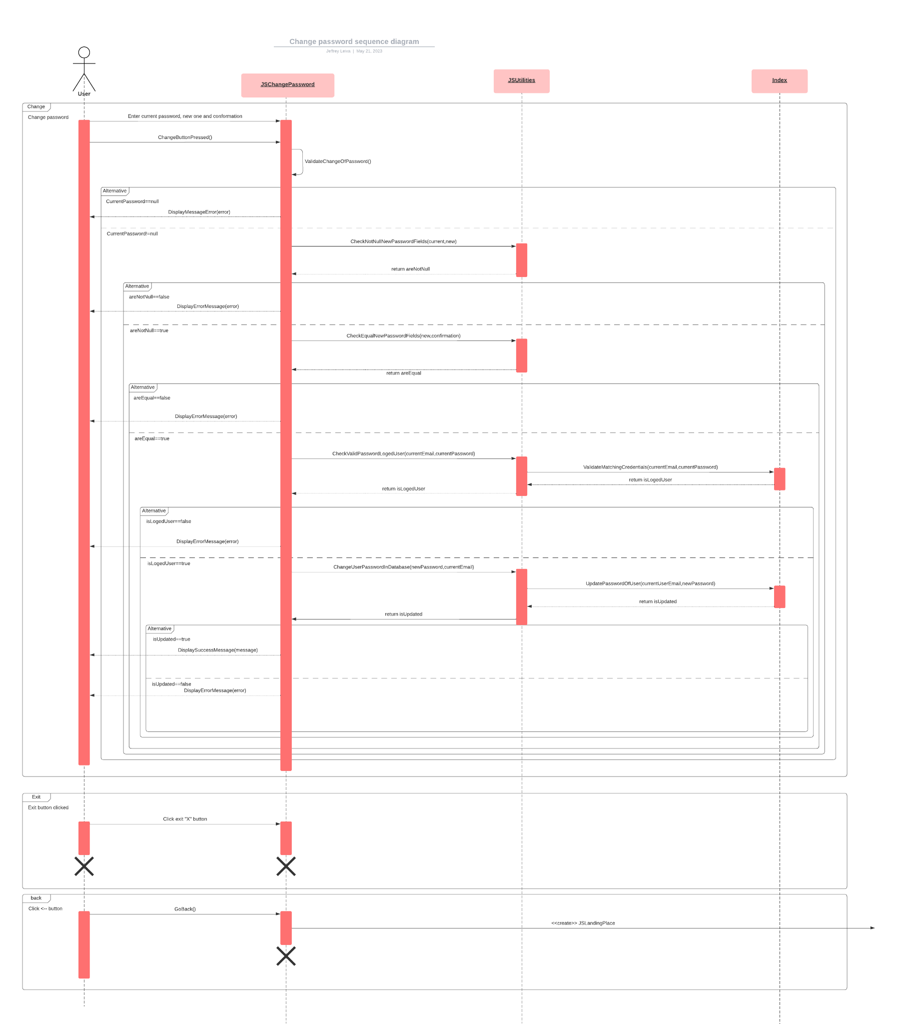
Figure 3.3.3.2.1: Change Password sequence diagram
- 3.3.3.3 Functional requirements:
- REQ-1: The System must show the Password Change Window and receive information.
- REQ-2: The system must create a new Password Change window object to display it.
- REQ-3: The system must create a new password change form window object to display it.
- REQ-4: The System must process the user's request, validate and consult and add to the user database. Go to figure 3.1
- REQ-5: The System verifies if the information is in the database and the account data is displayed.
- REQ-6: The system should display a message that the change was successful.
- REQ-7: The system must erase the memory belonging to the Password Change Window object once its use is finished.
- REQ-8: The system must clear the memory belonging to the Window object after its use has finished.
- REQ-9: The system must ensure that the database works correctly.
- REQ-10: The system must verify that the passwords match and that they comply with the established standards.
3.3.4 Manage Account:
- 3.3.4.1 Priority and description:
The diagram in the next section represents the execution sequence when the user wants to manage the account. First, when the authorized user should already be logged into the system, the Landing Place window display function is activated and the main application creates a new account management window object to display on the user's screen. Then, through the account management button, the user activates the function of using the account management form, the JSUtilities application creates a new Landing Place window object to display on the screen to the authorized user. JSUtilities frees the memory corresponding to the desktop window that was active for the session and ends its life cycle. Then the user fills in the required fields, then using the confirm button and having the JSUtilities program read the data and using the Verify if the data has a valid format function. If no problem occurs, the user will be registered in the database and a message that the data change was successful will be displayed on the user's screen. Finally, JSUtilities frees the memory corresponding to the account administration window that was active for the session and ends its life cycle.
- 3.3.4.2 Stimulus and Response Sequences:
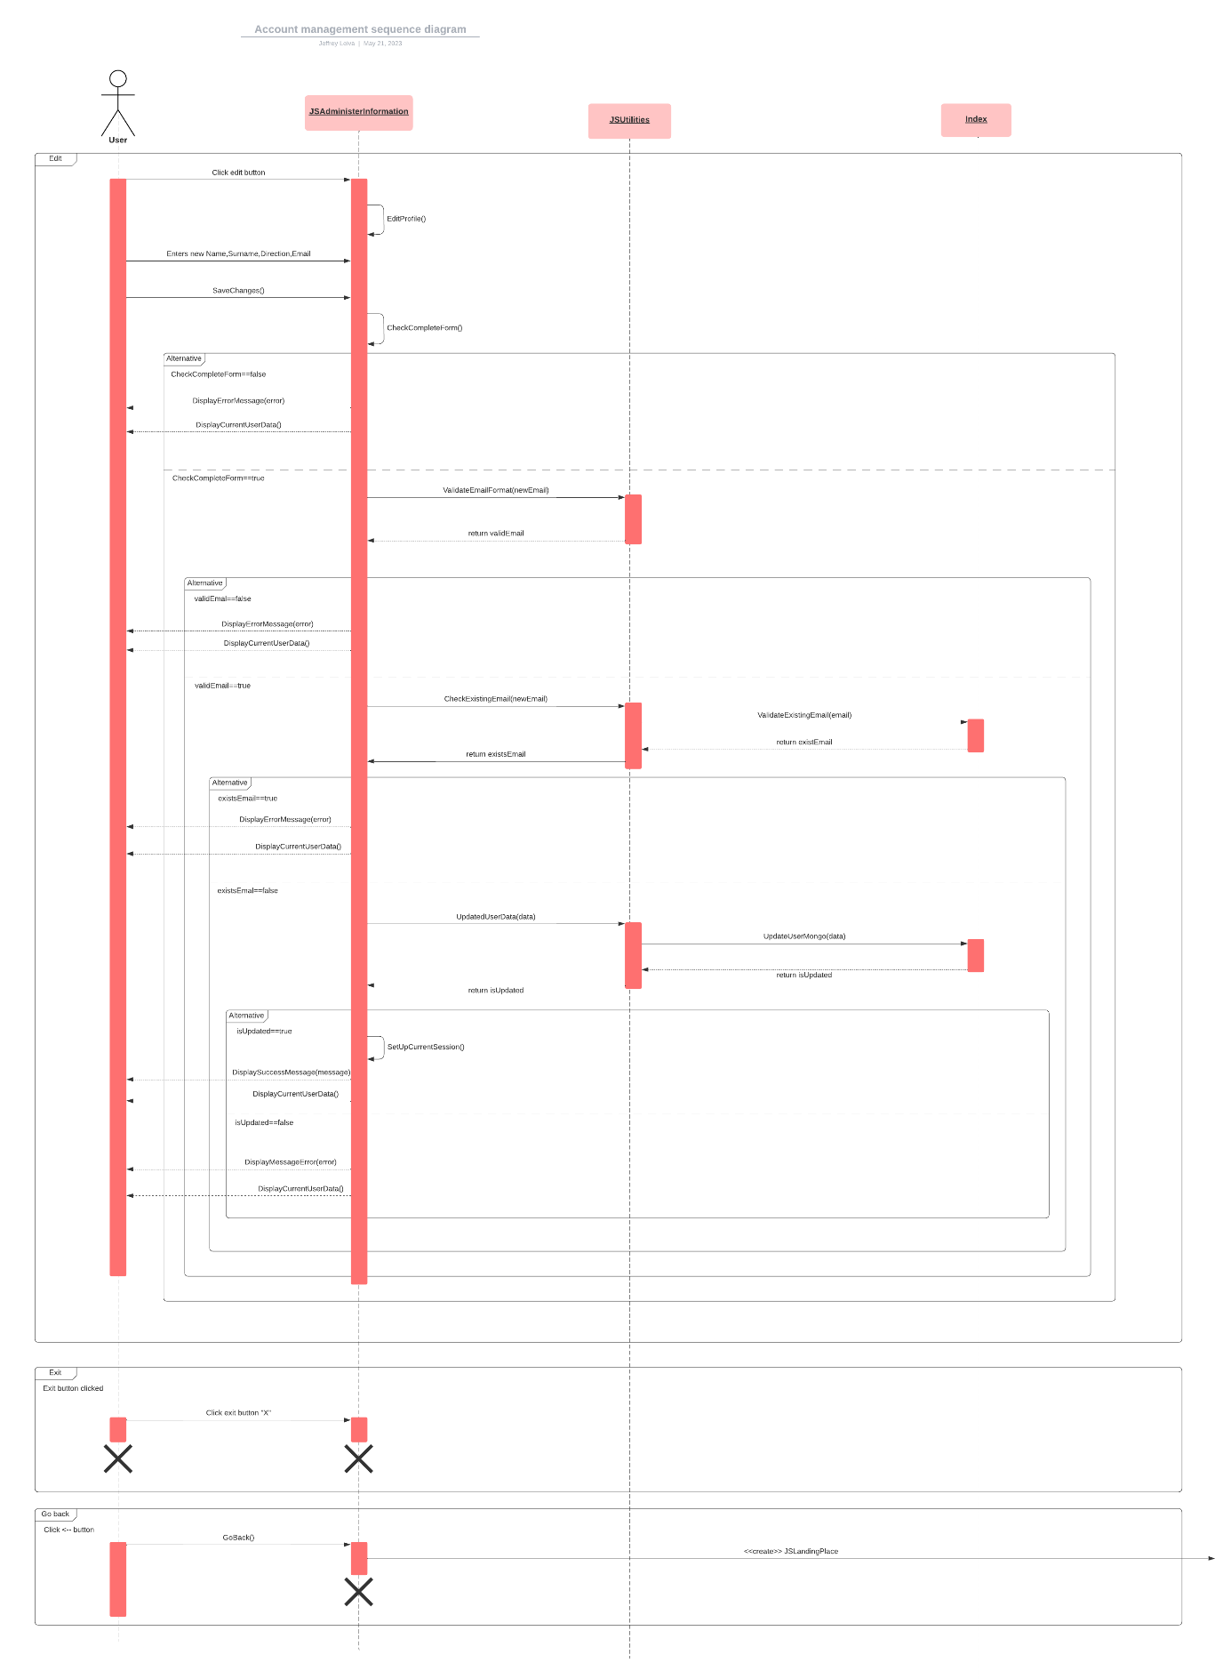
Figure 3.3.4.2.1: Change Password sequence diagram

- 3.3.4.3 Functional requirements:
- REQ-1: The System must show the Account Management Window and receive information.
- REQ-2: The system must create a new account management window object to display it.
- REQ-3: The system must create a new account management form window object to display it.
- REQ-4: The System must process the user's request, validate and consult and add to the user database. Go to figure 3.1
- REQ-5: The System verifies if the information is in the database and the account data is displayed.
- REQ-6: The system should display a message that the change was successful.
- REQ-7: The system must erase the memory belonging to the Account Management Window object once its use is finished.
- REQ-8: The system must clear the memory belonging to the Window object after its use has finished.
- REQ-9: The system must ensure that the database works correctly.

System Features
The authenticator system is divided into 5 interfaces aimed at both authorized and unauthorized users: login, landing place, information management, password change, and registration.

User interfaces
4.1.1 Log In Window.
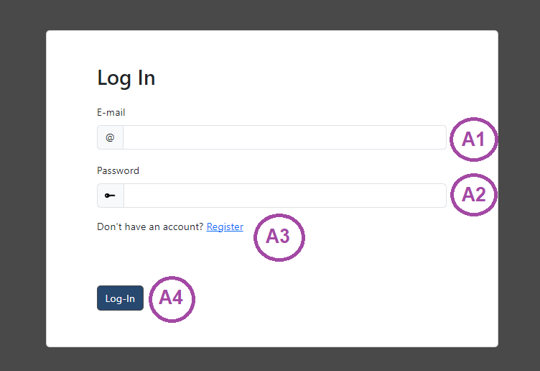
Figure 4.1.1: Log In Window.
4.1.1.1
Element | Space to type email.
Purpose | User email input field to log in.
Input | Keyboard.
Output | User email is displayed in the text field.
Validity | Must be an email with the valid format.
Error handling | Does not apply.
Relations | None.
Reference | Figure 4.1.1, element A1.

4.1.1.2
Element | Space to type password.
Purpose | User password input field to log in.
Input | Keyboard.
Output | The user's password is displayed in the masked text field.
Validity | The password cannot be empty.
Error handling | Does not apply.
Relations | None.
Reference | Figure 4.1.1, element A2.

4.1.1.3
Element | Register button.
Purpose | Allows the user to register a new account in the system.
Input | Mouse click.
Output | The user is redirected to the register window (4.1.5)
Validity | Click on the register button.
Error handling | Does not apply.
Relations | None.
Reference | Figure 4.1.1, element A3.

4.1.1.4
Element | Login button.
Purpose | Allows the user to log into the system.
Input | Mouse click.
Output | The user is redirected to the Landing Place if the login was successful; otherwise, the application will display a message specifying the error.
Validity | Click on the Login button.
Error handling | No field can be empty, the email must be valid, the user's email must exist in the database and the password must be correct respectively with the user's account in the system.
Relations | Related to the MongoDB database.
Reference | Figure 4.1.1, element A4.

4.1.2 Landing Place Window.
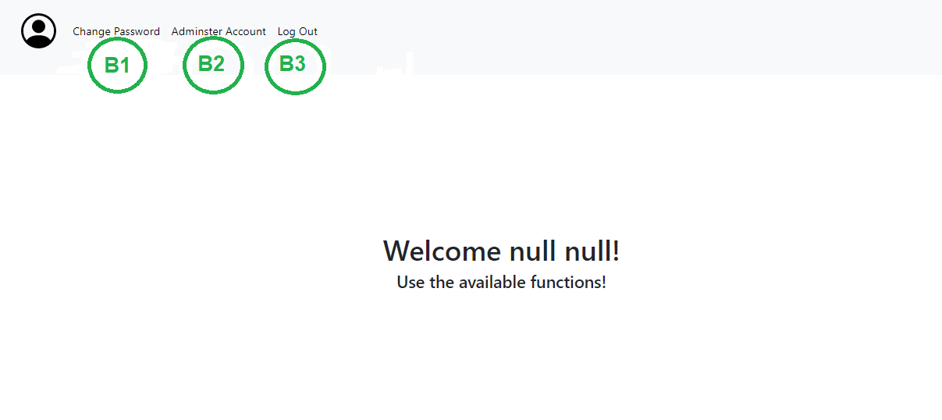
Figure 4.1.2: Landing Place.
4.1.2.1
Element | Change Password Button.
Purpose | Allows the user to change the password into the system.
Input | Mouse click.
Output | The user is redirected to the Change Password window.
Validity | Click on the change password button.
Error handling | Doesn’t apply.
Relations | None.
Reference | Figure 4.1.2, element B1.

4.1.2.2
Element | Administer Account Button.
Purpose | Allows the user to manage the account into the system.
Input | Mouse click
Output | The user is redirected to the Manage Account window. (4.1.3)
Validity | Click on the administer account button.
Error handling | Doesn’t apply.
Relations | None.
Reference | Figure 4.1.2, element B2.

4.1.2.3
Element | Logout button.
Purpose | Allows the user to logout of the system successfully.
Input | Mouse click.
Output | The user is redirected to the Login. (4.1.1)
Validity | Click on the logout button.
Error handling | Doesn’t apply.
Relations | None.
Reference | Figure 4.1.2, element B3.

4.1.3 Manage Information Window.
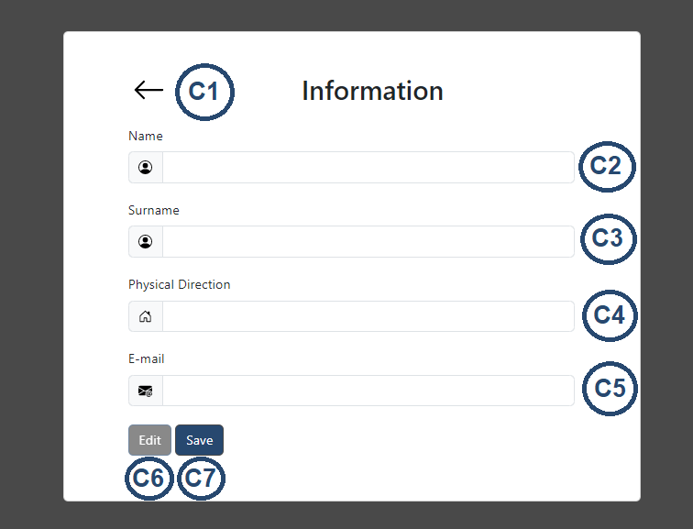
Figure 4.1.3: Manage Information
4.1.3.1
Element | Button to return to the previous window desktop(Landing Place).
Purpose | Allows the user to return to the Landing Place.
Input | Mouse click.
Output | The user is redirected to the Landing Place. (4.1.2)
Validity | Click on the button Return.
Error handling | Doesn’t apply.
Relations | None.
Reference | Figure 4.1.3, element C1.

4.1.3.2
Element | Space to type the new name of the user.
Purpose | User name input field to update.
Input | Keyboard
Output | User name is displayed in the text field.
Validity | Text field can’t be empty.
Error handling | The name must be a string and can’t be empty.
Relations | None
Reference | Figure 4.1.3, element C2.

4.1.3.3
Element | Space to type the new surname of the user.
Purpose | User surname input field to update.
Input | Keyboard
Output | User surname is displayed in the text field.
Validity | Text field can’t be empty.
Error handling | The surname must be a string and can’t be empty.
Relations | None
Reference | Figure 4.1.3, element C3.

4.1.3.4
Element | Space to type the new physical direction of the user.
Purpose | User physical direction input field to update.
Input | Keyboard
Output | User physical direction is displayed in the text field.
Validity | Text field can’t be empty.
Error handling | The physical direction must be a string and can’t be empty.
Relations | None
Reference | Figure 4.1.3, element C4.

4.1.3.5
Element | Space to type the new mail of the user.
Purpose | User mail input field to update.
Input | Keyboard
Output | User mail is displayed in the text field.
Validity | Must be an email with the valid format.
Error handling | Does not apply.
Relations | None
Reference | Figure 4.1.3, element C5.

4.1.3.6
Element | Button to edit the user information.
Purpose | Allow the user that the fields of their information are editable.
Input | Mouse click.
Output | Information fields can be edited
Validity | Click on the button Edit.
Error handling | Doesn’t apply.
Relations | None.
Reference | Figure 4.1.3, element C6.

4.1.3.7
Element | Button user to save information.
Purpose | Allow the user to save the changes about the information.
Input | Mouse click.
Output | Information fields are saved.
Validity | Click on the button Save.
Error handling | All the texts must be complete and with the valid format.
Relations | None.
Reference | Figure 4.1.3, element C7.

4.1.4 Change Password Window.
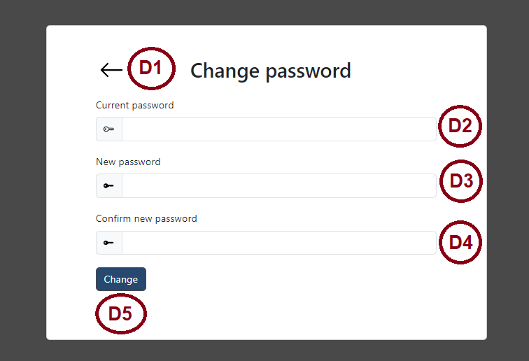
Figure 4.1.4: Change Password.
4.1.4.1

Element | Button to return to the previous window desktop(Landing Place).
Purpose | Allows the user to return to the Landing Place.
Input | Mouse click.
Output | The user is redirected to the Landing Place. (4.1.2)
Validity | Click on the button Return.
Error handling | Doesn’t apply.
Relations | None.
Reference | Figure 4.1.4, element D1.

4.1.4.2
Element | Space to type the current password of the user.
Purpose | User current password input field.
Input | Keyboard.
Output | The user current password is displayed in the masked text field.
Validity | The current password cannot be empty and need to match with the password in the database.
Error handling | Doesn’t Apply.
Relations | None
Reference | Figure 4.1.4, element D2.

4.1.4.3
Element | Space to type the new password of the user.
Purpose | User new password input field.
Input | Keyboard.
Output | The user new password is displayed in the masked text field.
Validity | The new password cannot be empty.
Error handling | Doesn’t Apply.
Relations | None
Reference | Figure 4.1.4, element D3.

4.1.4.4
Element | Space to type the confirmation of the new password.
Purpose | User new password input field.
Input | Keyboard.
Output | The user confirmation new password is displayed in the masked text field.
Validity | The confirmation of the new password cannot be empty.
Error handling | Doesn’t Apply.
Relations | None
Reference | Figure 4.1.4, element D4.

4.1.4.5
Element | Confirm changes button.
Purpose | Allows the user to save password changes.
Input | Mouse click.
Output | Password information is correctly updated in the database.
Validity | Click on the button changes.
Error handling | Doesn’t Apply.
Relations | None.
Reference | Figure 4.1.4, element D5.

4.1.5 Register Window.
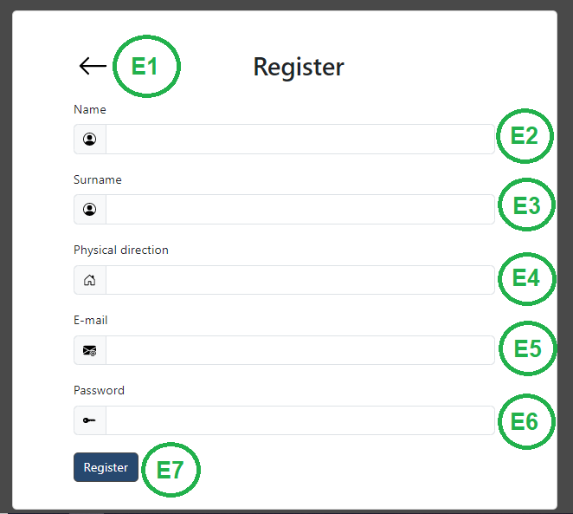
Figure 4.1.5: Register.
4.1.5.1

Element | Button to return to the previous window Log In.
Purpose | Allows the user to return to the Login.
Input | Mouse click.
Output | The user is redirected to the Login. (4.1.1)
Validity | Click on the button Return.
Error handling | Doesn’t apply.
Relations | None.
Reference | Figure 4.1.5, element E1.

4.1.5.2

Element | Space to type the name of the unauthorized user.
Purpose | Unauthorized user name input field..
Input | Keyboard
Output | Unauthorized user name is displayed in the text field.
Validity | Text field can’t be empty.
Error handling | The name must be a string and can’t be empty.
Relations | None
Reference | Figure 4.1.5, element E2.

4.1.5.3
Element | Space to type the surname of the unauthorized user.
Purpose | Unauthorized user surname input field..
Input | Keyboard
Output | Unauthorized user surname is displayed in the text field.
Validity | Text field can’t be empty.
Error handling | The surname must be a string and can’t be empty.
Relations | None
Reference | Figure 4.1.5, element E3.

4.1.5.4
Element | Space to type the physical direction of the unauthorized user.
Purpose | Unauthorized user physical direction input field..
Input | Keyboard
Output | Unauthorized user physical direction is displayed in the text field.
Validity | Text field can’t be empty.
Error handling | The physical direction must be a string and can’t be empty.
Relations | None
Reference | Figure 4.1.5, element E4.

4.1.5.5
Element | Space to type the mail of the unauthorized user.
Purpose | Unauthorized user mail input field.
Input | Keyboard
Output | Unauthorized user mail is displayed in the text field.
Validity | Must be an email with the valid format.
Error handling | Does not apply.
Relations | None
Reference | Figure 4.1.5, element E5.

4.1.5.6
Element | Space to type the current password of the unauthorized user.
Purpose | Unauthorized user password input field.
Input | Keyboard.
Output | The unauthorized user password is displayed in the masked text field.
Validity | The password can’t be empty.
Error handling | Doesn’t Apply.
Relations | None
Reference | Figure 4.1.5, element E6.

4.1.5.7
Element | Register button.
Purpose | Allows the unauthorized user successfully register in the system.
Input | Mouse click.
Output | The user is successfully registered into the system.
Validity | Click on the button register.
Error handling | All data must be in the valid format and no text space must be empty.
Relations | None.
Reference | Figure 4.1.5, element E7.

Other Nonfunctional Requirements

Performance Requirements
The functions described and developed in the system must respond in less than 5 seconds, because due to issues of performance and efficiency, the user should not wait long for a correct response from the system. The system is designed to serve one user at a time due to the domain that depends entirely on the computer, however several can be connected from different computers in the system, only it does not work through a public URL or through a service hosting separately.
The database saves each change efficiently and quickly, which allows the system a high level of consistency and availability for your data.

Safety Requirements
The system adheres to the security regulations in force in the programming and does not present a risk to the integrity of human lives in any aspect.

Security Requirements
- The password was encrypted and is masked for the normal user and the unauthorized one, in any functionality of the system it is found in this way for security terms and also if the database suffers an attack the encrypted information is more difficult to understand. All this is not under any business rule but rather following international software security guidelines and good programming practices.
- Within the code, descriptive names are used, but certain controlled changes are made to variables and so on, because if the system is hacked, it is not so easy to understand how the parameters are passed in the database and also to access more of the system.

Software Quality Attributes
- The usability of the system follows Microsoft standards, with all text boxes and buttons providing a simple user-friendly interface.
- Following the idea that the system will be used in a university, it should adhere to business rules that allow users to use the system completely self-administered without the help of a third party.
- The system works with any browser based on Google Chrome. This increases access by eliminating the need for special external software to restrict usage. Bootstrap may cause problems in other browsers.

Business Rules
- The system must be created with the guidance of Microsoft Like.

Other Requirements
The token system database that represents the persistent data of the application consists mainly of the user entity present in a non-relational database and is described below:
User: document in MongoDB where the database stores the users who have registered.
- Object ID: Automatically generated by the database.
- Name: String
Attribute in charge of storing the first name of the user.
- Surname: String
Attribute in charge of storing the first surname of the user.
- Physical address: String
Attribute in charge of storing the address of the user.
- Mai;:String
Attribute in charge of storing the user's email address.
- Password: String
Attribute in charge of storing the user's encrypted password.
Appendix A: Glossary
Authenticator System: It is a software that limits and allows the registration of unauthorized users.
Bootstrap is a free and open source CSS framework aimed at mobile and responsive front-end web development.
CSS: A style sheet language used to describe the presentation of a document written in a markup language such as HTML.
Desktop: refers to the window where the system functionalities are found.
Express: It is a Javascript library, it is designed to create web applications and APIs.
Front-End: is the practice of converting data to a graphical interface, through the use of HTML, CSS, and JavaScript, so that users can view and interact with that data.
HTML: HyperText Markup Language.
IDE: Integrated Development Environment.
JavaScript: It is a programming or scripting language that allows you to implement complex functions in web pages.
Main: It is where the program begins its execution. It is the function that controls the flow of the program.
MongoDB: is a non-relational database management system.
Node.js – Asynchronous event-driven Javascript runtime that can build scalable networked applications.
Non-relational: is one that does not use the tabular layout of rows and columns.
Blind: Function that prevents you from seeing what was written in a text field.
Responsive: It is a design and development philosophy whose objective is to adapt the appearance of web pages to the device that is being used to visit them.
Salt – Comprises random bits that are used as one of the inputs in a key-derivative function.
Self-service: It is a philosophy that establishes that the user attends to himself, does not need any employee to carry out an action.
Unauthorized user: person that is not registered on the system and has no access to the system.
User: person that is registered on the system and has access to the system, The user of the system can be any person from the university, be it principal, financial principal, students, teachers, administrative and providers.
Appendix B: Analysis Models
Appendix B.1: Use case diagram.

Appendix B.2: Class diagram.
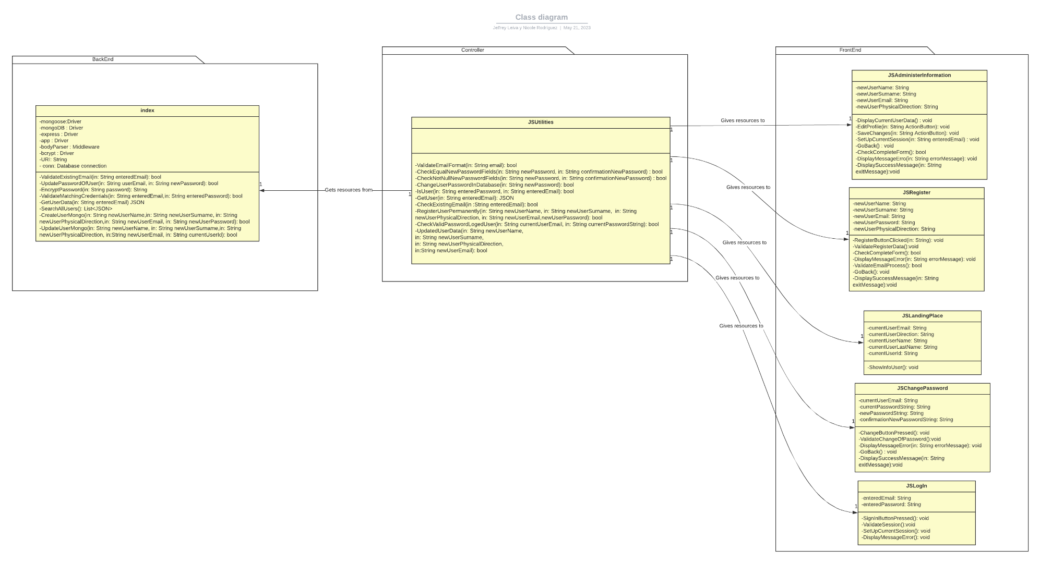
Data dictionary:
User: document in MongoDB where the database stores the users who have registered.

- Object ID: Automatically generated by the database.
- Name: String
Attribute in charge of storing the first name of the user.
- Surname: String
Attribute in charge of storing the first surname of the user.
- Physical address: String
Attribute in charge of storing the address of the user.
- Mai;:String
Attribute in charge of storing the user's email address.
- Password: String
Attribute in charge of storing the user's encrypted password.

Index
name |  | Comments
Index |  | Class that allows us to manage the system from the back end.
Parameters | Type | Comments
mongoose | driver | Driver to use the applications of Mongoose.
Mongodb | driver | Driver to use the applications of Mongoose.
express | driver | Driver to use library express.
app | driver | Driver to use node.js
bodyParser | Middleware | Component part of encryption.
bycrpt | driver | Component part of encryption.
URL | string | String for connection to MongoDB.
conn | database connection | String for connection to MongoDB.

JS Administer Information
name |  | Comments
JS Administer Information |  | System window to manage user information.
Parameters | Type | Comments
newUserName | string | New user name.
newUserSurname | string | New user surname.
newUserEmail | string | New User Email.
newUserPhysicalDirection | string | New User Physical Direction.

JS Register
name |  | Comments
JS Register |  | System window to register unauthorized user.
Parameters | Type | Comments
newUserName | string | New unauthorized user name.
newUserSurname | string | New unauthorized user. surname.
newUserEmail | string | New unauthorized user. Email.
newUserPhysicalDirection | string | New unauthorized user.Physical Direction.
newUserPassword | string | New unauthorized user.password.

JSLandingPlace
name |  | Comments
JSLandingPlace |  | System window for desktop (Landing Place).
Parameters | Type | Comments
currentEmailUser | string | Current user Email.
currentUserDirection | string | Current user Direction.
currentUserName | string | Current user Name.
currentUserLastName | string | Current user Surname.
currentUserID | string | Current user ID.

JSChangePassword
name |  | Comments
JSChangePassword |  | System window for functionality Change Password.
Parameters | Type | Comments
currentEmailUser | string | Current user Email.
currentPasswordString | string | Current user password.
newPasswordString | string | New user password.
confirmationNewPasswordString | string | Confirmation new user password.

JSLogIn
name |  | Comments
JSLogIn |  | System window Login.
Parameters | Type | Comments
enteredEmail | string | Unauthorized user email.
enteredPassword | string | Unauthorized user password.

Appendix B.3: Sequence diagrams.
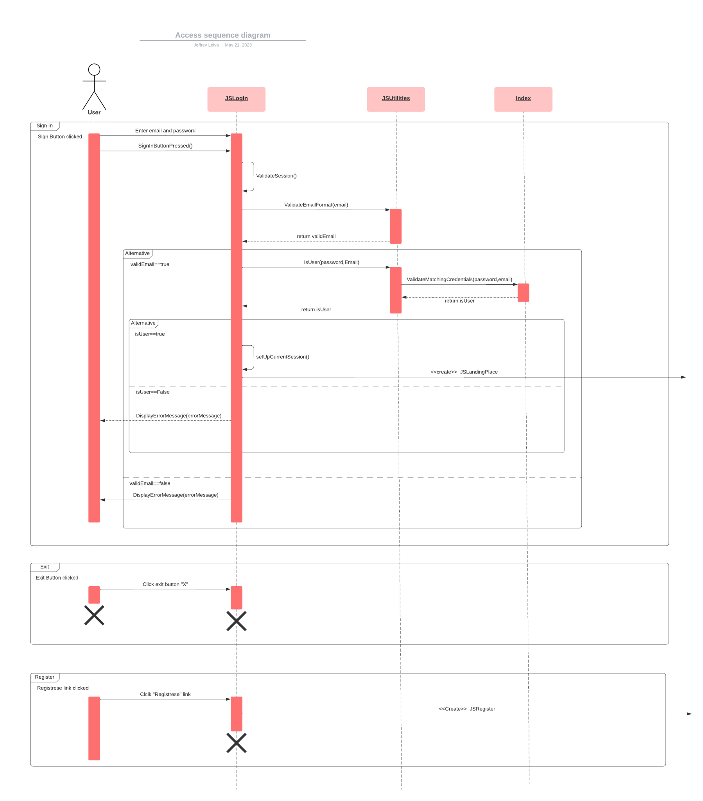
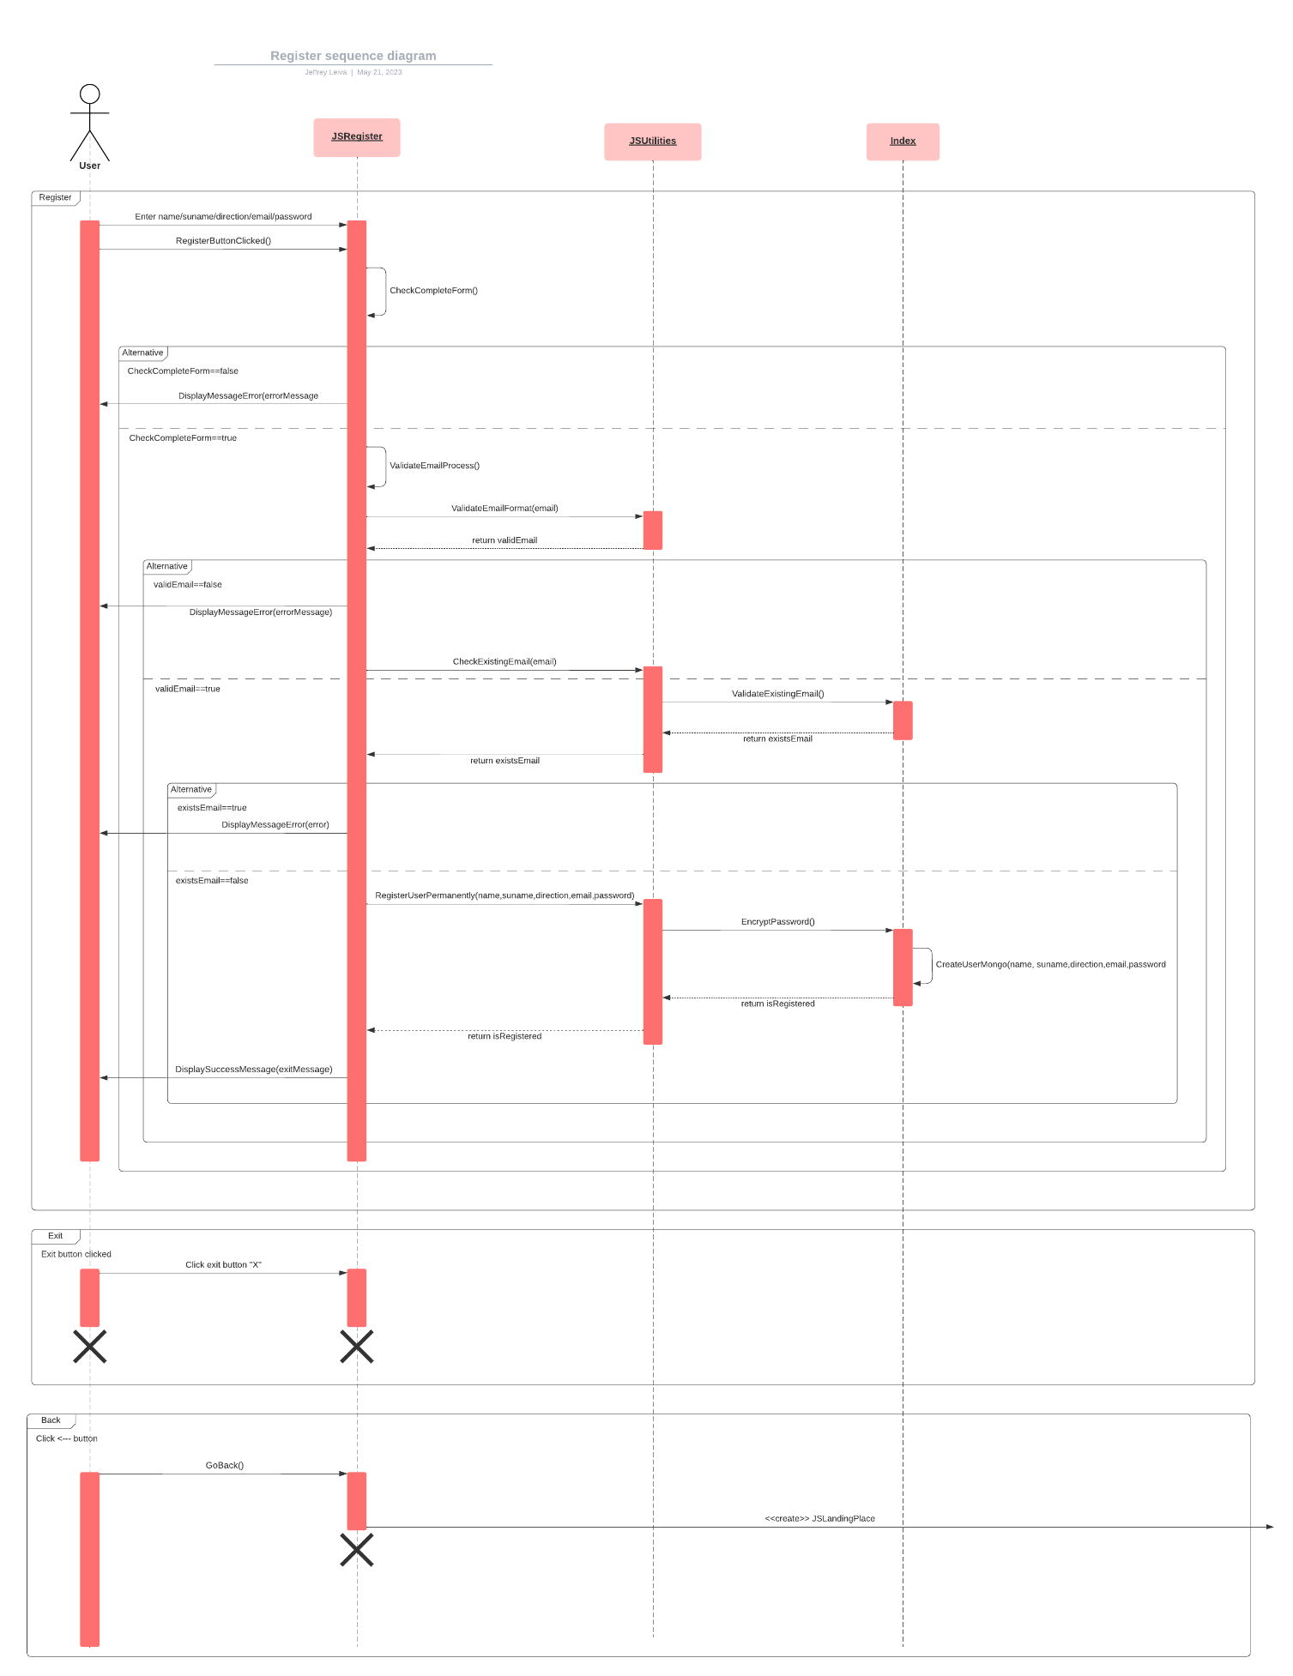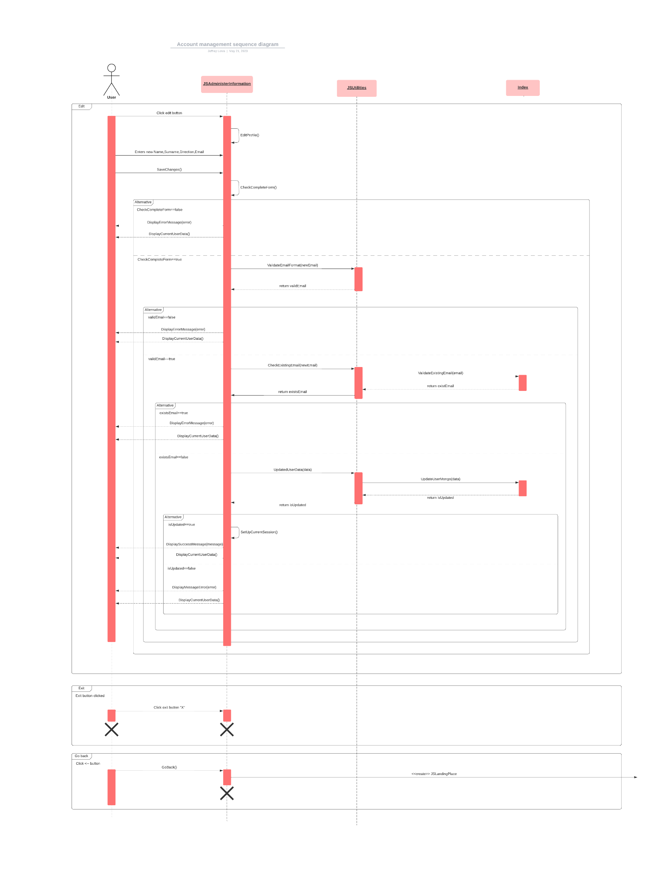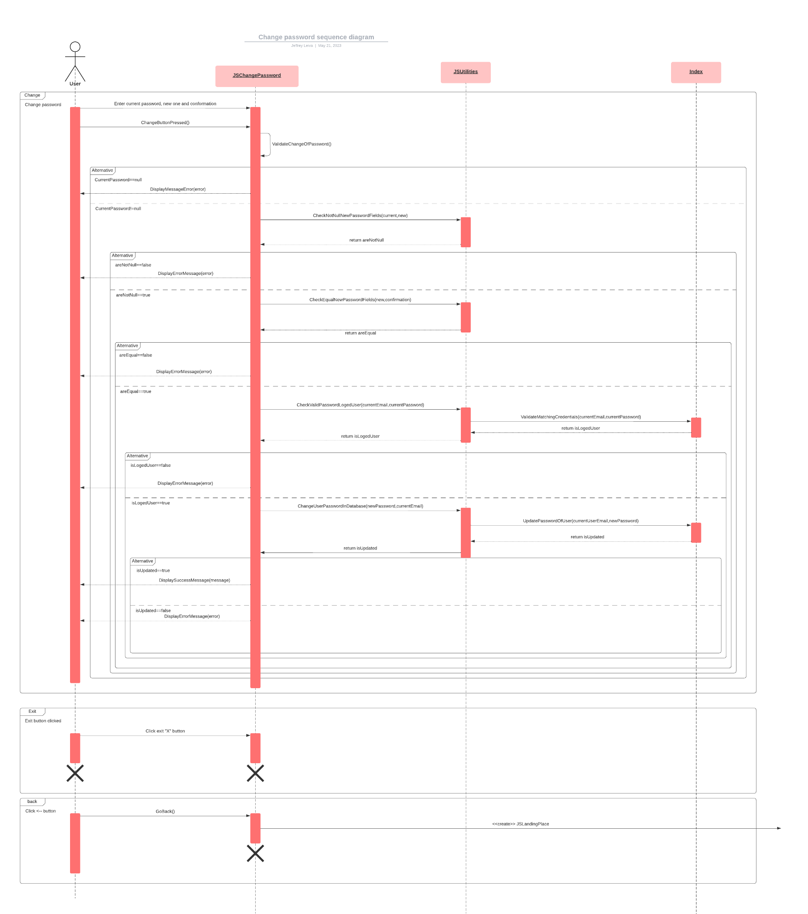
Appendix C: To Be Determined List
Doesn’t Apply.

